**California State University East Bay**

Prescriptive Analytics (MGMT 6165)

Winter Quarter 2017

Instructor: Dr. Zinovy Radovilsky

**Samsung Corporate’s Facebook Advertising Model**

Chi Nguyen

Trung Phan

Thao Dinh

Anton Kurayev

March, 2017

**TABLE OF CONTENTS**

SUMMARY 2

INTRODUCTION 3

MAIN CHAPTER 4

1. Data Description 4

2. Model Formulation 6

2.1 Decision Variables 6

2.2 Objective Function 7

2.3 Constraints 7

3. Optimal Solution 9

4. Sensitivity Analysis (Solver Table) 10

5. Extension of the Model 15

CONCLUSION 17

BIBLIOGRAPHY 19

# **SUMMARY**

South Korean multinational conglomerate Samsung with its Vietnam Corporate has recently decided to implement an optimization model to increase their brand recognition to Vietnamese youth through Facebook social media fan pages by using a viral campaign called “Value in Trend”. The model includes different viewers age group categories and fan pages with its costs, numbers of exposure, and minimum required exposures per post. The main objective of the advertising model is to find out how many posts to buy on each fan page to obtain the minimum required number of exposures with a minimal total cost by using Excel Solver and Excel SolverTable tools. The Facebook advertising model implementation led to the number of exposures that Samsung might get in return, optimal choice of how many advertising posts the company should place on each page, and optimal cost solution that the company could spend for running advertising campaign on Facebook fan communities.

# **INTRODUCTION**

Samsung Vietnam Corporate aims to increase their brand awareness to Vietnamese youth generation through social media. Partnering with Isobar Vietnam, a digital marketing agency, Samsung Vietnam Corporate run a viral campaign called “Value in Trend”. The company creates a video with a message of how young people can create their own trend and define themselves in the crowd with Samsung products. Samsung wants to spread out this message through a variety of Facebook channels. The digital marketing agency has conducted a research and suggested Samsung’s brand manager a list of Facebook fan pages that are suitable to deliver the campaign’s messages. The company will place different posts about the video on these fan pages. The posts in different Facebook fan pages vary by cost and by the types of fans they are likely to reach. The post viewers on Facebook are classified into six categories:

* Men 13-17 years old
* Men 18-24 years old
* Men 25-34 years old
* Women 13-17 years old
* Women 18-24 years old
* Women 25-34 years old

The company has determined the minimal required number of views it wants to obtain for each group. Also, since Samsung does not want their posts to be placed heavily on a fan page, the company requires that the number of posts of each page must be greater than 1 and less than 20% of total posts. This will help the video’s message to be spread to diverse audience among the channels. The company wants to know how many posts to buy on each of several fan pages to obtain the minimal required number of exposures with a minimum cost.

# **MAIN CHAPTER**

## **1. Data Description**

Based on a suggested list of fan pages from the digital marketing agency, Samsung will place different posts on nine pages which are Hoi Doc Than, Nhat Ky, Hoi Nhung Nguoi Yeu Do Choi Cong Nghe, 365 daband, Cuong Seven, Tuong Vi, An Nguy, Huyme and Thanh Duy Idol. Those are popular and influential fan pages to Vietnamese young generation. Each fan page belongs to a well-known Vietnamese artist or a popular social community.

**Hoi Doc Than (*The Singles Group*)** is a fan page of young and singles community. The content theme of this page is about single life, fun and trending news. The page has 2,890,290 fans in total. **Nhat Ky (*Diary*)** fan page centralizes on emotional and inspiration stories for its community. The page is liked mostly by female fans who are in the age range of 13 to 24. This group takes up to 62% of total number of fans of the page which is 2,349,894 fans. **Hoi Nhung Nguoi Yeu Do Choi Cong Nghe (*People Who Love Tech and Gadgets*)** is a fan page of tech-lovers and gadget-obsessed community. In total, it has about 194,587 fans and the biggest proportions of its fan base is men from 18 to 34 years old. **365 daband** is the fan page of a music boyband called *365*. They are one of the most famous boybands in Vietnam and have a wide range of fans. Totally there are 3,442,100 fans following their Facebook page. **Cuong Seven** and **Thanh Duy Idol** are young, talented singers in Vietnam. Their fan pages are one-stop places for their fans to keep updated about and interact with the singers. Respectively, they have 211,069 fans and 676,735 fans. **Tuong Vi** is a successful actress with leading roles in Vietnamese’s favorite movies. She got 341,216 fan on her page. **An Nguy** and **Huyme** are hot Youtubers in the Internet community of Vietnam. Their Youtube videos attract millions of views and usually discuss topics about the young. An Nguy owns 3,284,221 fans and Huyme got 1,411,230 fans.

Using Facebook Insights, the owner of each fan page provides the data on the numbers of fans in each age group. Those fans will be able to see any post published on the Facebook page of which they are fans. Each such post viewer is called exposure. Samsung has determined the required number of exposures it wants to obtain for each group.

The data on costs per post, numbers of exposures per post, and minimum required exposures are listed in the table below.

|  |  |  |  |  |  |  |  |  |  |  |
| --- | --- | --- | --- | --- | --- | --- | --- | --- | --- | --- |
| Fan-page  Viewer Group | The Singles  Group  (1) | Diary  (2) | People Who Love Tech & Gadget (3) | 365 daband (4) | Cuong Seven (5) | Tuong Vi  (6) | An Nguy (7) | Huyme (8) | Thanh Duy Idol (9) | Minimal Required Exposures |
| Men  13-17 | **578,058** | **70,497** | **23,350** | **516,315** | **35,882** | **27,297** | **525,475** | **141,123** | **47,371** | **6,000,000** |
| Men  18-24 | **635,864** | **234,989** | **58,376** | **688,420** | **48,546** | **51,182** | **689,686** | **296,358** | **155,649** | **10,000,000** |
| Men  25-34 | **260,126** | **187,992** | **81,727** | **206,526** | **6,332** | **17,061** | **131,369** | **211,685** | **74,441** | **3,000,000** |
| Women 13-17 | **549,155** | **328,985** | **3,697** | **688,420** | **63,321** | **61,419** | **788,213** | **197,572** | **108,278** | **9,000,000** |
| Women 18-24 | **520,252** | **1,127,949** | **15,567** | **929,367** | **42,214** | **109,189** | **853,897** | **437,481** | **250,392** | **15,000,000** |
| Women 25-34 | **346,835** | **399,482** | **11,675** | **413,052** | **14,775** | **75,068** | **295,580** | **127,011** | **40,604** | **5,000,000** |
| Cost per post (VND) | **6,500,000** | **5,000,000** | **1,500,000** | **8,000,000** | **2,500,000** | **3,500,000** | **9,000,000** | **4,000,000** | **8,000,000** |  |

The advertising costs per post are the going rates for a post for the various kinds of fan page on Facebook.

The required numbers of exposures are determined internally by Samsung Vietnam. The company’s brand manager knows which population groups are the best audiences for their viral video and has some sense of the number of exposures the company should obtain to achieve their marketing goals. As we can see from the table above, among six groups, the age group of 18 – 24 has the highest number of minimal required exposures which is 25,000,000 exposures in total. This indicates that Samsung mainly targets on young audience. This strategy is reasonable for their goal which is to raise the brand awareness to the young generation.

## **2. Model Formulation**

To find the optimal solution for minimizing the total advertising cost that Samsung intend to spend on online posts, we use Integer Programming Model and run Solver add-in in Excel to get results.

### **2.1 Decision Variables**

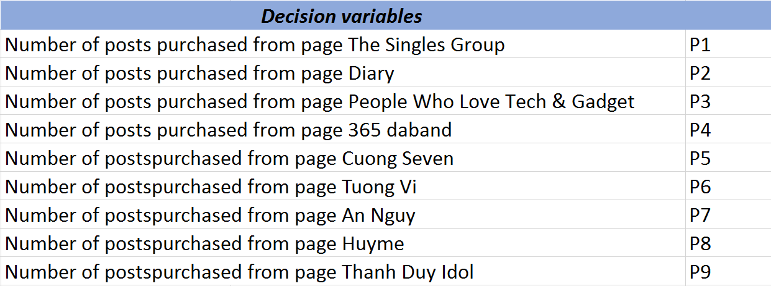Samsung wants to figure out how many posts to be posted in each fan pages; thus, the decision variables of the model will be the number of posts purchased from the nine selected fan pages.

### **2.2 Objective Function**

The objective of this model is to minimize the total expenses on purchasing posts from nine fan pages. The formula expression of the total cost is presented as below:

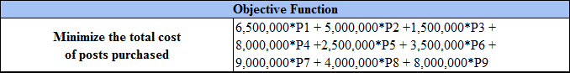

### **2.3 Constraints**

There are four main constraints in this model. First, the total exposures of each group must be equal or greater than the minimal required number of exposures for that group. This constraint helps Samsung make sure that their viral campaign can covers a specific amount of audience in the online community so that the brand awareness among those groups of people will be increased.

Second, the number of posts purchased from each fan page must be at least 1. Each of the nine fan pages has its own kind of fans since each page has different directions of content to attract its fans. Therefore, Samsung wants their posts to be placed in every fan pages so the brand’s messages can reach to a diverse body of viewers.

Third, the number of posts on each page should not exceed 20 percent of total number of posts purchased from all of nine pages. Again, Samsung set this constraint because they do not want one page will dominate on placing its posts. The company wants to keep the diversity of its post viewers.

Fourth, the number of posts to buy must be integers.

The formula expression of each constraint is described as following:

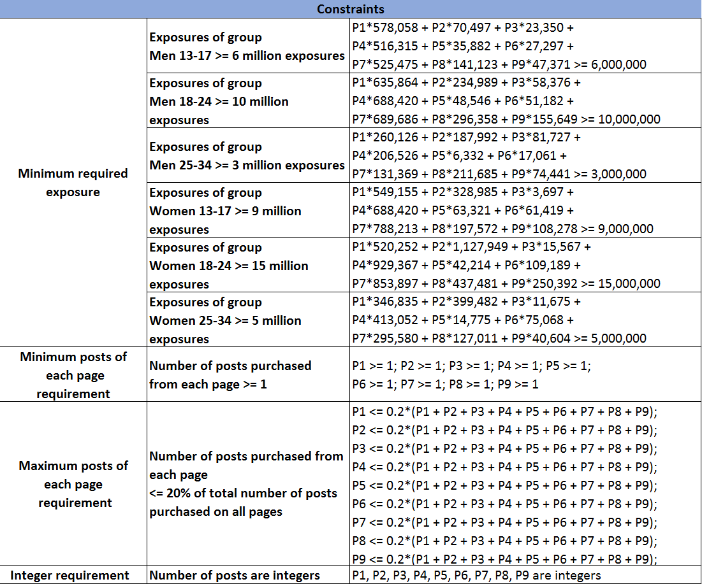

## **Screen Clipping3. Optimal Solution**

Based on the result from Solver, the optimal cost that Samsung could obtain for running advertising posts on Facebook fan pages is VND138.5 million which is paid for total 25 posts. In detail, following the optimal plan, the company should place 5 posts on fan pages of The Singles Group, 365 daband and Huyme; 4 posts on Diary page; 2 posts on People Who Love Tech & Gadget; and 1 post on Cuong Seven, Tuong Vi, An Nguy and Thanh Duy Idol page.

In terms of Samsung's expectation, if Samsung implements the purchase plan based on the optimal solution, the company can expect a pretty high number of exposures in return. There will be totally over 53 million exposures to Samsung’s advertising posts on the selected fan pages, which is 5 million more exposures than the total minimum required number. This means with the optimal cost of VND 138.5 million, Samsung not only achieves its requirement of 48 million exposures, but also get extra 5 million exposures.

## **4. Sensitivity Analysis (Solver Table)**

Using Solver Table for this Integer Programming Model, we study on how the optimal cost varies if number of required exposures change. Specifically, we run one-way sensitivity analysis for the RHS of the minimum required exposure constraints in the model (Cell $D$26, $D$27, $D$28, $D$29, $D$30 and $D$31) to see the effect on the optimal cost of changing the required number of exposures of each group from 1 million to 20 million with an increment of 1 million.

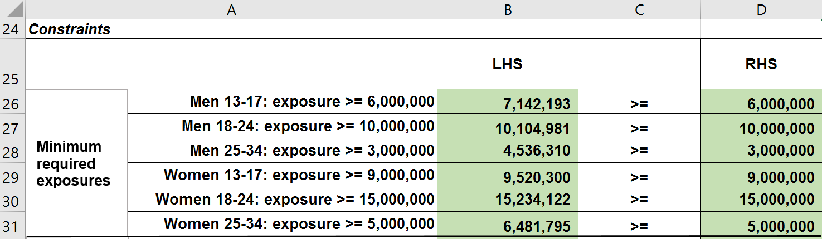

The SolverTable results are presented in Figure 1.1, Figure 1.2, Figure 1.3, Figure 1.4, Figure 1.5 and Figure 1.6.

**Figure 1.1** Sensitivity of total cost to the change in required exposures of group Men 13-17

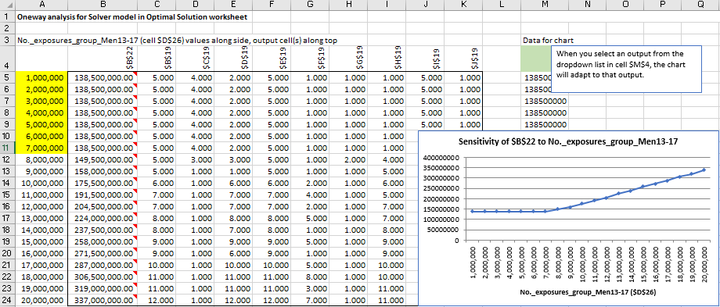

The results of this analysis show that if the required exposures of group Men 13-17 are between 1 million to 7 million, the total cost remains the same which is at VND138.5 million. Above 7 million and up to 20 million exposures, the total cost increases sharply from VND138.5 million to VND337 million. Therefore, if the company would like to increase the minimum required exposures for this group up to 7 million, it is still accepted since the increase does not affect the total cost. However, if the company would like to increase the required exposures more than 7 million, it needs to consider the change carefully because this change will affect the optimal cost.

**Figure 1.2** Sensitivity of total cost to the change in required exposures of group Men 18-24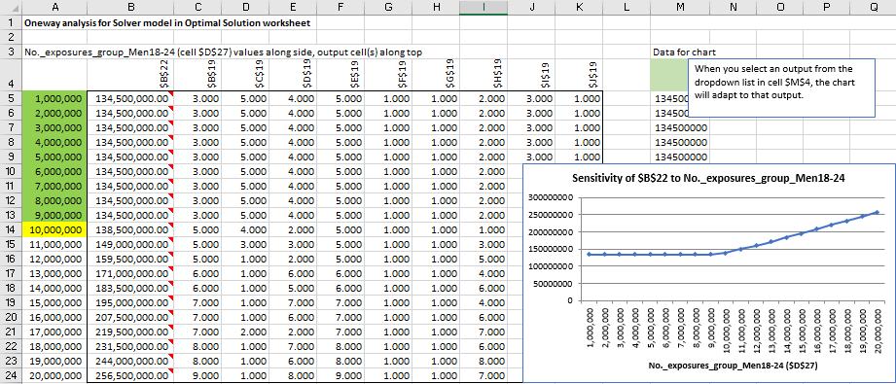

The results of this analysis illustrate that if the required exposures of group Men 18-24 are in the range of 1,000,000 to 9,000,000, the total cost stays the same, which is at VND134,500,000. Above 9,000,000 and up to 20,000,000, the total cost keeps increasing from VND138,500,000 to VND256,500,000. Hence, in case Samsung would like to increase the current required number of exposures for group Men 18-24 above 10 million, the company should be aware that the change will raise up the total cost dramatically.

**Figure 1.3** Sensitivity of total cost to the change in required exposures of group Men 25-34

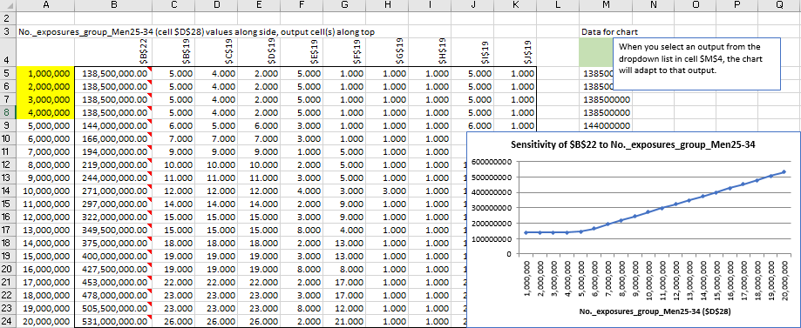

From the **Figure 1.3**, we can see that when the required number of exposures of group Men 25-34 varies from 1,000,000 to 4,000,000, the total cost is insensitive to that change. It still maintains at VND138,500,000. Above 4,000,000 and up to 20,000,000, the total cost increases from VND138,500,000 to VND531,000,000. If the company would like to increase the current required exposures for this group, which is 3 million, by 1 million exposures, it still can get the optimal cost of VND138.5 million. Above than 4 million exposures, the company must spend a bigger budget on its social advertising campaign.

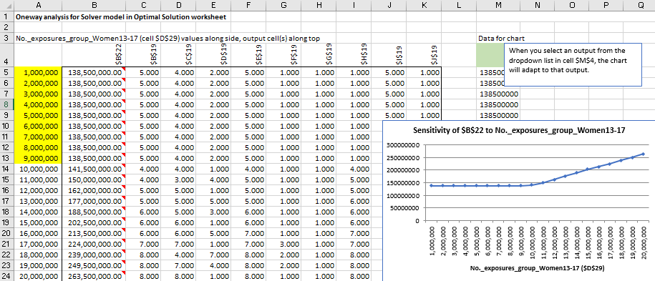 **Figure 1.4** Sensitivity of total cost to the change in required exposures of group Women 13-17

From the results of this analysis, we can see that between 1,000,000 and 9,000,000, the required number of exposures of group Women 13-17 does not change the optimal cost which remains at VND138,500,000. Above 9,000,000 and up to 20,000,000, the total cost keeps increasing from VND138,500,000 to VND263,500,000. Therefore, in case the company would like to increase the current required number of exposures more than 9,000,000, it should consider that a higher cost will occur. We may not recommend the company to boost the number of exposures for this group.

**Figure 1.5** Sensitivity of total cost to the change in required exposures of group Women 18-24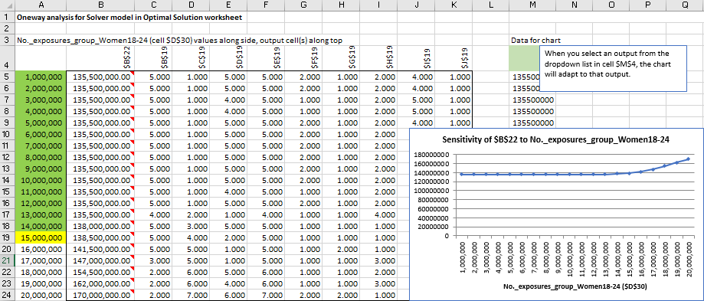

The **Figure 1.5** indicates that in a scale of 1,000,000 to 15,000,000, the required number of exposures of group Women 18-24 does not change the optimal cost which stays at VND138,500,000. Above 15,000,000 and up to 20,000,000, the total cost increase significantly from VND138,500,000 to VND170,000,000. Thus, if the company would like to increase the required exposure more than 15,000,000, the optimal cost will change considerably. We may not recommend the company to require higher exposures for this group.

**Figure 1.6** Sensitivity of total cost to the change in required exposures of group Women 25-34

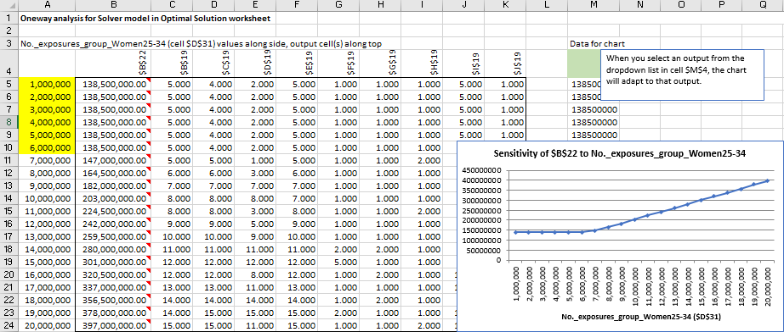

The results of this analysis show that the total cost remains at VND138,500,000 when the required number of exposures varies from 1 million to 6 million. Above 6 million and up to 20 million, the total cost grows sharply from VND138,500,000 to VND397,000,000. Therefore, if the company would like to require a minimum exposure higher than 6 million for this group, it should prepare a bigger budget on the social advertising plan.

Overall, after running one-way Solver Table for the RHS of the required number of exposures of each group, we can conclude that with group Men 13-17, group Men 25-34, group Women 25-34, if the company would like to require 1 million more exposures than its current requirement, it is acceptable because the total cost is not affected. However, with the other groups (group Men 18-24, group Women 13-17 and group Women 18-24), the company should consider that the increase in the required number of exposures will lead to a significant increase of the total cost.

## **5. Extension of the Model**

Samsung advertising model can be extended in a very natural way. The company has two competing objectives: obtain as many exposures, and keep the total advertising cost as low as possible. In the optimization model, we decided to minimize total advertising cost and constrain the exposures to be at least as large as a required level. We want to have an alternative that is to maximize the total number of exposures and put a budget constraint in total cost. Our excess exposures are the above the minimal required level. We changed the Objective Function to maximize Total Excess Exposures and add Budget (Total Cost) constraint. We set the budget of VND150,000,000. Extended model is shown below:

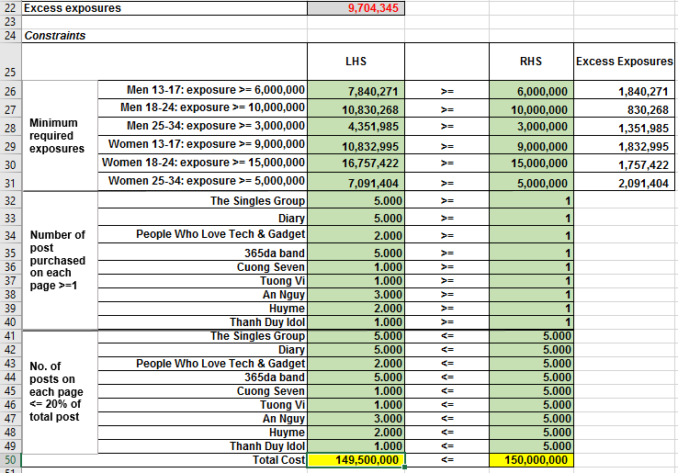

After running one-way sensitivity SolverTable for a desired budget range we can say that for low budget from VND137,000,000 to VND138,000,000 the problem is infeasible - there is no way with this budget to obtain the minimal required exposures. As the budget increases from VND138,500,000 to VND150,000,000 the company can clearly become feasible and may obtain larger numbers of excess exposures. In our case, we set the budget of VND150,000,000 that eventually when Samsung authorize to spend more on advertising and it will give excess exposures of 9,704,345 compare to the optimal solution of 5,019,701, which is obviously give 4,684,644 more total excess exposures. Sensitivity analysis for an extended model as below:

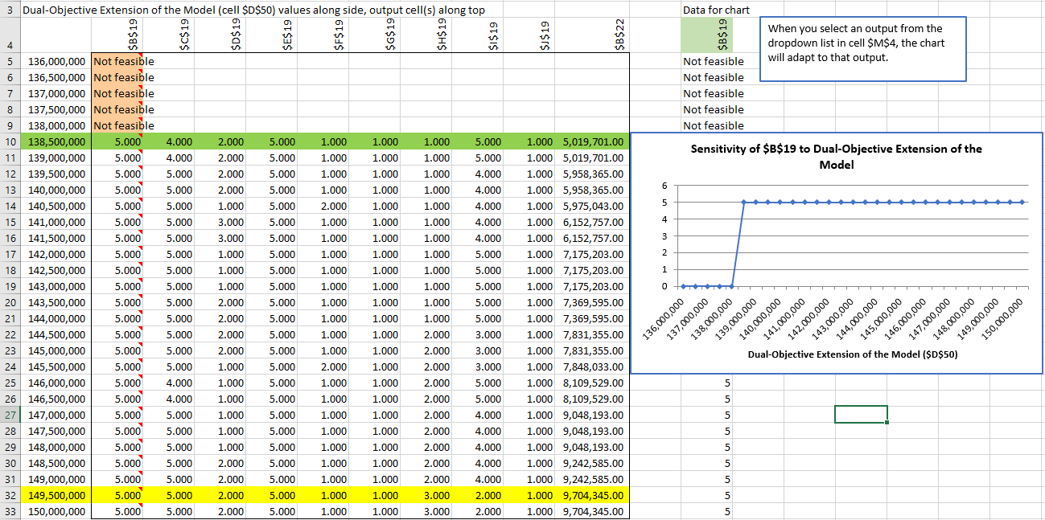

# **CONCLUSION**

In this paper, by using Excel Solver and Excel SolverTable add-in tools, we demonstrated the optimal solution for Samsung Vietnam Corporate advertising campaign on Facebook social media conducted by a digital marketing agency. Based on the Excel optimization model we built, we successfully found the solution for the main goal to acquire the number of posts that the company should buy from each of nine fan pages to obtain the minimum required number of exposures with a minimum cost.

The results based on Excel Solver optimization model show us that the optimal cost that Samsung could achieve for running advertising campaign on Facebook is VND138.5 million for total of 25 posts on nine different fan groups. Moreover, if the company decided to implement the purchase based on the optimal cost they could expect a significant growth of exposures from required 48 million to over 53 million. Hence, we recommend Samsung to adopt the given model to increase brand awareness among young people in six different age categories for men and women in a range between 13 and 34 years old. The only minor limitation of the model is that we will not be able to know the data for viewers that out of our age categories, but it might be easily to study out by adding additional constraints to our model, if needed.

Our group found additional study by running one-way sensitivity analysis using Excel SolverTable tool. The goal of this study is to see how the optimal cost may vary if the numbers of required exposures among each of six age categories of viewers alter from 1 million to 20 million with a step of 1 million. The results show that some increases in a certain range of exposures may increase or remain the same the current optimal cost. From here, if the company decide to increase the required exposures by a certain number for any of age groups (Men 18-24, Women 13-17, and Women 18-24), they need to consider that it will affect the optimal cost significantly. On the other hand, some small changes in exposure (by 1 million) for certain groups (Men 13-17, Men 25-34, Women 25-34) are acceptable, since the total cost will not be affected. All in all, we cannot recommend the company to increase the required number of exposures significantly.

We decided to go further and create an extension for the model for Samsung advertising campaign. In this model, we maximize the total number of exposures by changing the Objective Function and add additional budget constraint in total cost (VND150,000,000). After running one-way sensitivity analysis for a set budget, we can conclude that when the company is allowed to spend more on advertising, it will get more total excess exposures.

# **BIBLIOGRAPHY**

Winston, W.L. and Albright. (2016) S.C. Practical Management Science, 5thEdition, , Cengage Learning.